

In Your Orbit

Team Inventory

Cloud-Based Planetary Ephemerides

United States Geological Survey

Mentor: Scott Larocca

Austin Carlile

Noah Schwartz

Minuka Trikawalagoda

Nicholas Gonzalez

The purpose of this team inventory document is to briefly introduce the team and outline the relevant training, skills, and experience of each team member

9/30/2024

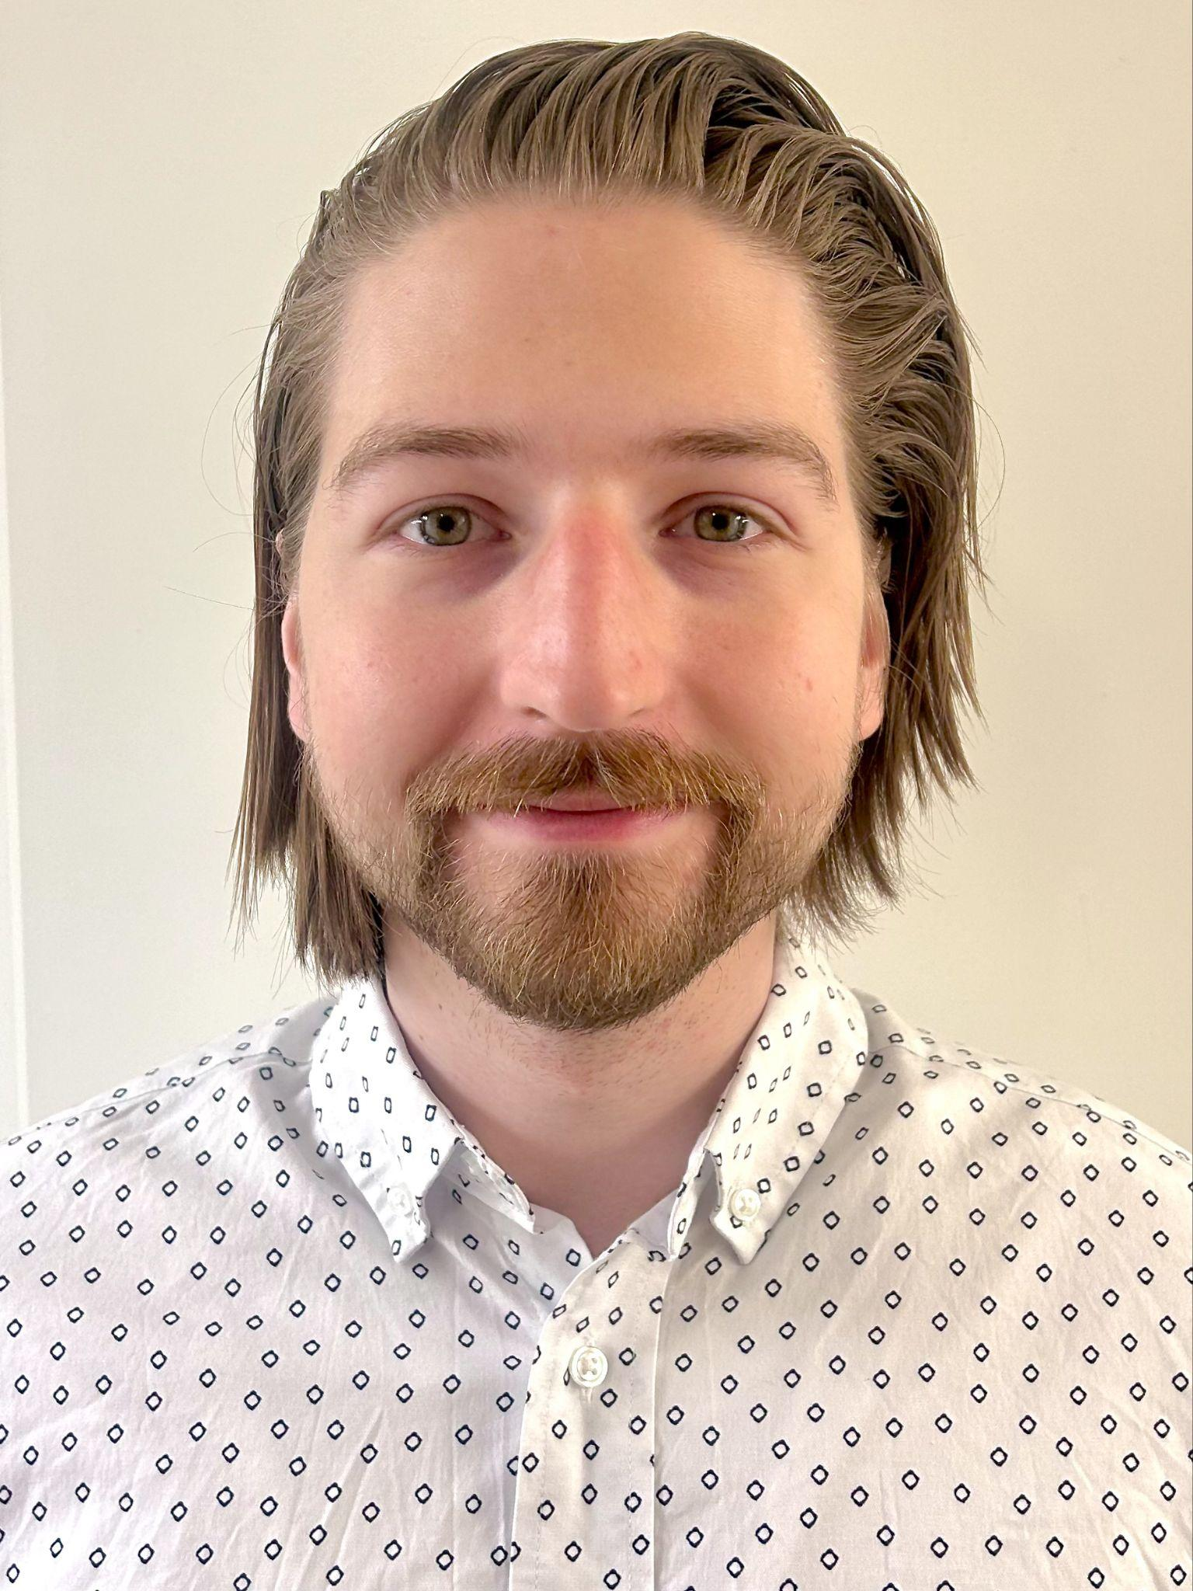Austin Carlile

Computer Science

Juneau, Alaska

**Education:**

* Juneau-Douglas High School
* Northern Arizona University:
  + Database Systems
  + Computer Networks
  + Web Programming II

**Work Experience:**

* Wostmann Associates Internship: Created .NET Web APIs for SQL databases.

**Skills:**

* Web APIs: Created ASP.NET Web APIs during my internship at Wostmann Associates.
* Web Pages: Created all aspects of various web pages during my Web Programming I & II courses.
* Client/Server Architecture: Created client and server applications, including a chat room program during my Computer Networks course.

**Interests**:

* Music: I enjoy creating music, I played violin for a couple years and am currently learning to play guitar.
* Art: I like to draw both physically and digitally, I paint a little and would like to do more.
* Hiking: I grew up surrounded by nature and mountains, I love to hike up mountains.
* Machine learning: I find the concept of an algorithmically self-improving program to be fascinating.

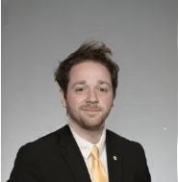Noah Schwartz

Software Engineering

Phoenix, Arizona

**Education:**

* Scottsdale Preparatory Academy
  + GPA: 4.29
* Northern Arizona University:
  + Database Systems
  + Software Architecture
  + Web Programming II

**Work Experience:**

* Freelance Work: Helped develop a website for a Licensed Clinical Social Worker’s practice

**Skills:**

* Web Pages: Created various web pages during the Web Programming I & II courses, knowledge is working but not expert.
* Software Architecture: Developed a web application that called to an API for information to display on the site built on a Client-Server and Pipe-Filter architecture, knowledge is working but not expert.
* Database Systems: Working knowledge of SQL commands and querying with some experience integrating with Python programs.

**Interests**:

* Sports: I did baseball and football in high school, and I still enjoy playing or just playing catch with friends when I can.
* Aviation: I was originally going to attend Embry-Riddle as an Aeronautical Engineering major which leads to a commercial pilot’s license but last minute I switched to NAU. I still plan to obtain my private pilot’s license once I secure good Software Engineering money.
* Music: I have tried to pick up various instruments throughout my life, I used to play violin when I was young. I enjoy listening to music and helping friends who make their own music with what criticism I feel inclined to provide.

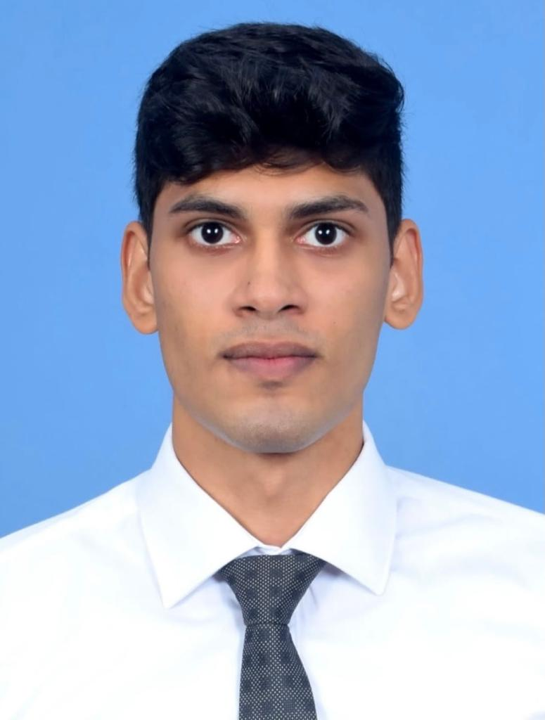

Minuka Trikawalagoda

Computer Science

Colombo, Sri Lanka

**Education:**

* S. Thomas’ Preparatory School, Sri Lanka
* Northern Arizona University:
  + Software Architecture
  + Software engineering
  + Web Programming II

**Work Experience:**

* Teaching Assistant - Computer Science at Northern Arizona University
* Intern: Systems Administrator for Giga Foods (Pvt) Ltd, Colombo, Sri Lanka

**Skills:**

* Web Development: Hands-on experience creating web pages during Web Programming I & II courses. Proficient in foundational web technologies, though still developing advanced expertise.
* Application Architecture: Built a web application that fetches data from an external API and displays it on the front end. Applied Client-Server and Pipe-Filter architectures with a solid working understanding of these design principles.

**Interests**:

* I'm passionate about sports, actively involved in rugby and swimming, though I enjoy a wide variety of activities.
* Music is another interest of mine; I play the piano, guitar, saxophone, and trumpet.
* I also enjoy building and creating projects, and I'm currently working on building a fpv drone.

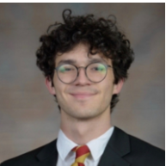

Nicholas Gonzalez

Computer Science

Peoria, Arizona

**Education:**

* Liberty High School
* Northern Arizona University:
  + Software Engineering
  + Algorithms
  + Web Programming II

**Work Experience:**

* Freelance Work: Built a website for a self-ran jewelry business that operated as a shopping platform

**Skills:**

* Web Pages: Developed numerous websites in CS212 as well as for personal projects, largely with an emphasis in UX.
* User Experience (UX) Design: Built a business website that was designed for ease of use in a shopping environment
* Algorithms: Working knowledge of advanced algorithms with past and current coursework focused on the topic

**Interests**:

* Music: I have played guitar for about 5 years and enjoy writing both the instrumental and vocal compositions of songs.
* Woodworking: I enjoy keeping myself busy with physical projects around my house as well as small personal projects. It is a good challenge for me to work with a limited budget to try to achieve a high end functionality within my works.
* GIS: I have not delved as deeply into GIS as I’d like to, but have been taking many geography classes and have started using some GIS tools. I am looking to start an online course in GIS this winter to get more applicable and fine-tuned practice.